* Overall aspect of the website. Front page

The front page needs to be attractive and give envy to look at the others

Templates should suggest the visual identity of the ED logo (blue and orange) as many times as possible.

Catching formula (care and cure, serve and protect, eat and drink…) to be identified

Insert a bubble “Facts” mentioning the total estimate number of patients in Europe, the number of family connections and meetings in each association member, the quality and expertise of European scientific labs and Universities and the EC source of funding. Will work on that at the Bordeaux meeting.

Insert a “breaking news” bubble in the front page, easy to fill and frequently update

Miscellaneous. Insert camcha to protect the registration form from robots (many attacks today). Replace Danish representative. 12 flags image instead of 11.

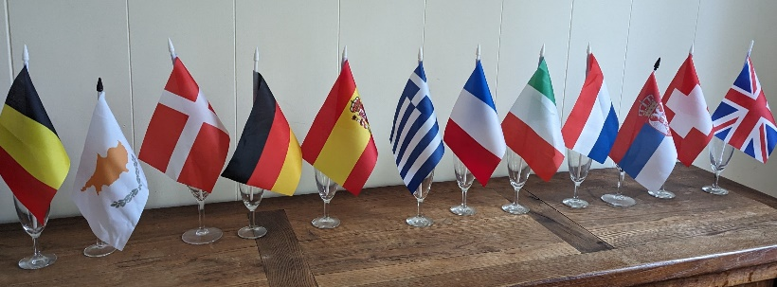

* Page number 2. Statutory page

Use as many links and buttons as possible better than hard text

Statutes, house rules 🡪 Link towards the documents

Associations registered in ED 🡪 1 line per association + link

Scientific Advisory Board 🡪 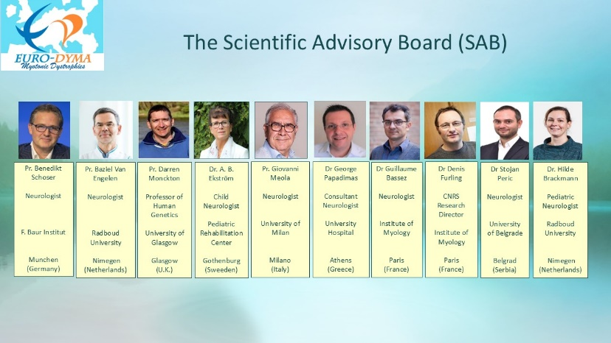

Board representatives list 🡪 same aspect as SAB

* Page number 3. Documentation

Highlight the Myobase database which is multilanguage, and has its own engine to sort documents

For the others, adopt buttons to select language edition or country provenance or…else

Highlight guidelines (MDF)

* Page number 4. Programs

Recognition, SIMPATHIC, ANIQ, PALADIN, training of doctorands (2025), MDF collaboration (future)

* Page number 5. Events

ED Pharma’s Day, ENMC meetings, IDMC, MDF conference, family days or other events organized by members in their country, DM day in September

* Page number 6. Clinical trials

Links towards clinicaltrials.gov and the MDF pipeline. Link to pharma homepages.

* Page number 7. Communication tools

Euro-DyMA access numbers and emails, social media

Blog. We don’t have enough human resources to maintain it alive. May be in a later version.